BLINKIT ONLINE LAUNDRY MANAGEMENT SYSTEM
FACULTY; SIR AFFAN MUGHAL
BATCH CODE; AI-202408B
COURSE; HDSE I



“NO NEED TO WORRY WHEN BLINKIT IS HERE”

CERTIFICATE OF COMPLETION

STUDENT ID | NAME
1596275 | M. RAYAN ASIF
1597553 | NOMAN ALI
1595674 | WALEED KHAN
1595675 | DANISH SHEIKHANI

This is to certify that these Students of APTECH COMPUTER EDUCATON has successfully completed the E-Project [ BLINKIT ONLINE LAUNDRY MANAGEMENT SYSTEM], The project has been developed as a part of curriculum requirements for the course [HDSE I], This project involves the development of a web-based application for managing laundry services, covering Customer Management, Order Processing, Admin Reporting, Providing seamless smooth environment
Sr. No. | Table Of Content | Page No.
1. | Problem Definition & Solution | 3
2. | Customer Requirement Specification (CRS) | 3
3. | Project Plan (Timeline) | 4
4. | Data Flow Diagram | 5
5. | Flowchart | 6
6. | E-R Diagrams (Database Design) | 7
7. | Interface Design Document (Screenshots) | 5
8. | Final Check List | 14

|Problem Statement
With busy schedules, it’s easy to let that pile of laundry on your chair just keep growing. Instead of waiting for the local dhobi to show up, laundry services, which offer online booking and door-to-door pick-up and delivery! Online Laundry System is an Integrated System of Laundries functional work, organize and maintain the Data necessary for operations. Online Laundry System has modules to manage Customer Invoices for Pieces, weight, Package, Delivery of Piece, weight, Package wise, and Barcode Generations many more. It has a fully-fledged Human Resource module to manage the payroll and pay slips.
Solution
To address these issues, we have developed the "BlinkIt Online Laundry Management System". This is an integrated web-based platform that automates the entire laundry cycle. We have implemented the specific requirements outlined in the project scope as follows:
- Registration & Access Control: We replaced manual registers with a secure Customer Registration Module so customers can register and avail are offers and book their laundry. The Admin has full rights to view, edit, and manage customers data securely.

- Versatile Pricing Models: Understanding that laundry needs vary, we have implemented three distinct invoicing methods:
  - Piece-Wise Invoice: For individual expensive items (e.g., Suits, Jackets, Hoodies, Blanket, etc.).
  - Weight-Wise Invoice: For bulk washing (The customer may select weight wise Package in which quantities are mentioned).
  - Package-Wise Invoice: Monthly subscription plans (Student/Premium packages in which no of pieces of clothes are fixed).

- Tracking & Transparency: To solve the issue of lost clothes, we integrated Barcode Generation. A unique barcode is generated on the invoice for every order to tag and track clothes efficiently so the clothes wont get misplaced as customer satisfaction is our first priority

- Real-Time Updates: The system features SMS/Chat Integration to update customers instantly when their order status changes (e.g., from Processing to Delivered).This keeps the customer not only give updates regarding their booking which they have made also they gave a good impact that we care about their clothes which helps in making good connections in future and win trust

- Business Intelligence: We created a User-Friendly Dashboard and robust Reporting Modules (Cash Book, Daily Collection, Garment-wise Revenue, Staff Sheet, Payroll) to help the Admin track financial growth, track its employee details & salaries also pending payments effortlessly so that we can know that is the business going in loss or profit
.
|Project Timeline
Phase | Activity | Status
1 | Requirement Analysis | COMPLETED
2 | Database Design (ER - Diagram) | COMPLETED
3 | Data Flow Diagram | COMPLETED
4 | Flowchart | COMPLETED
5 | UI Design (HTML/CSS) | COMPLETED
6 | Testing & Debugging | COMPLETED
7 | Documentation | COMPLETED

|Data Flow Diagram
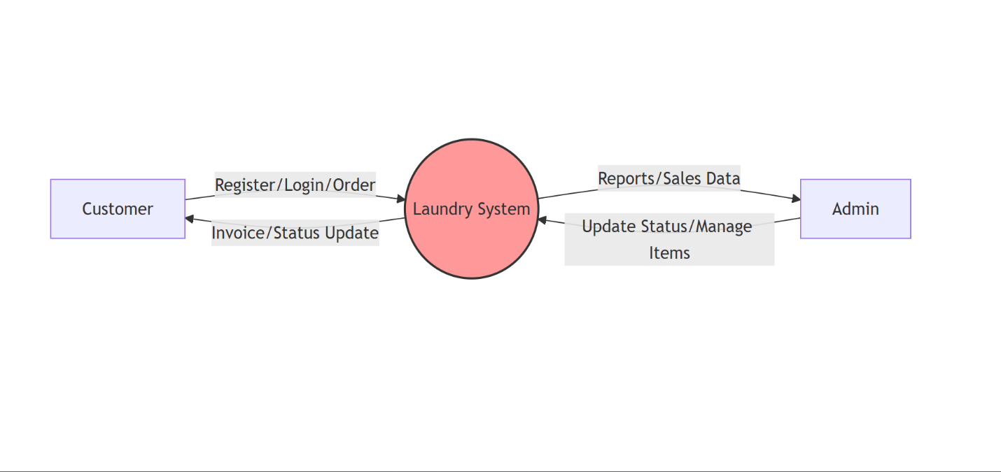

Figure 1.1: Data Flow Diagram (Context Diagram)

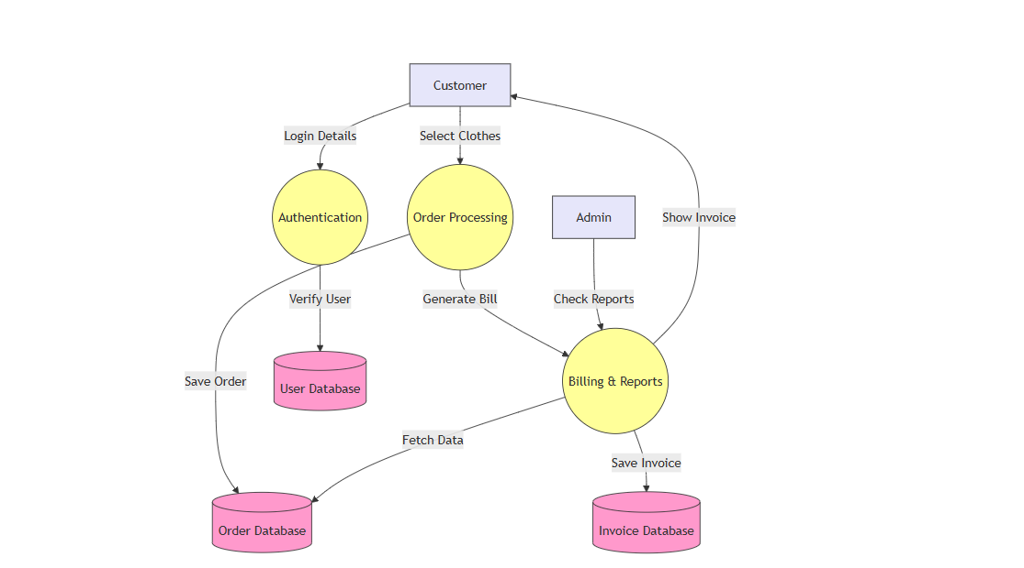
Figure 1.2: Data Flow Diagram (Detailed Diagram)

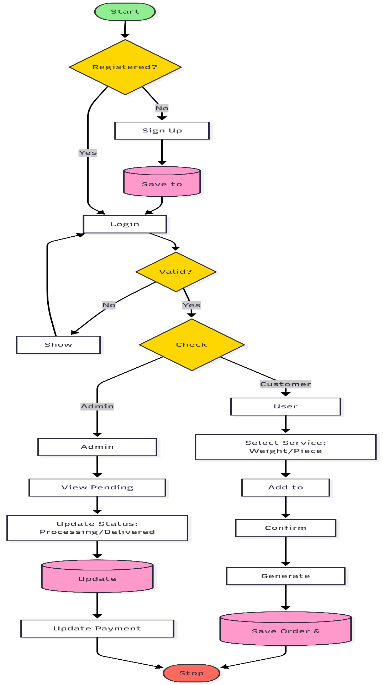
|Flow Chart

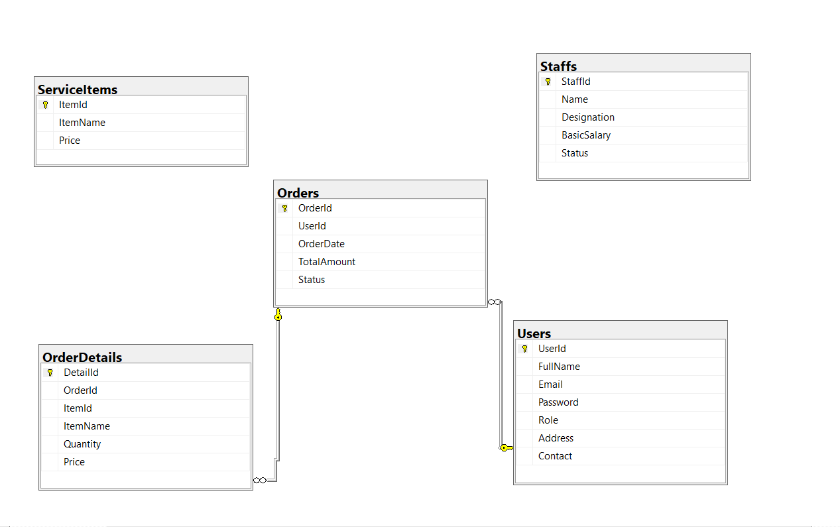
|ER – Diagram

| Interface Design Document (Screenshots)
1.HomePage
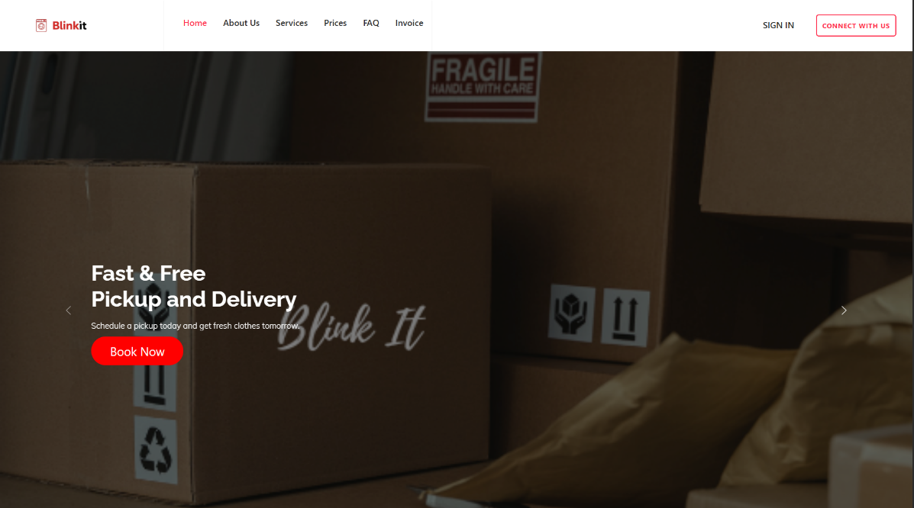

2.Login Page

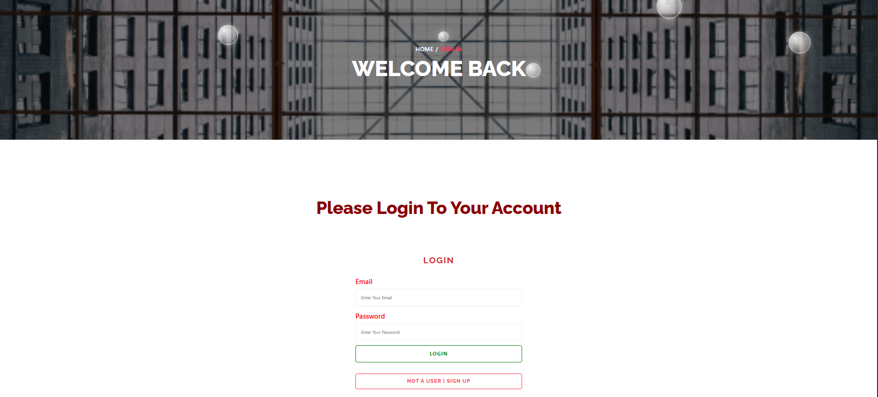

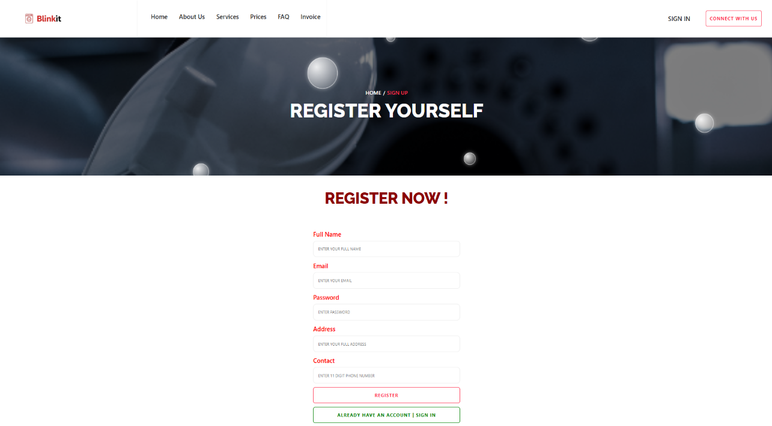
3.Register Page

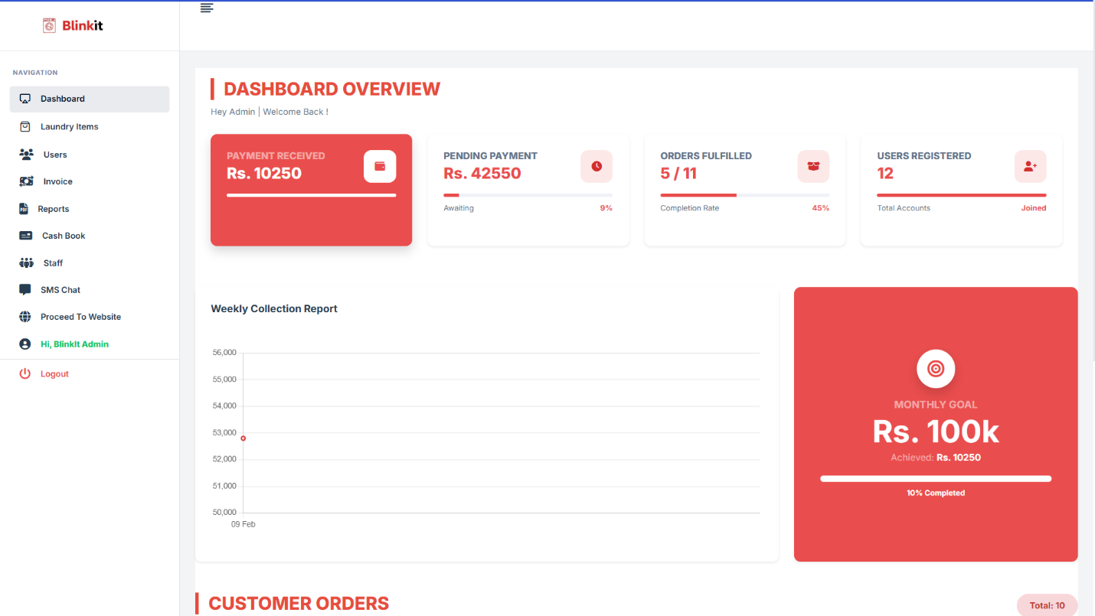
4.ADMIN DASHBOARD

5.Customer Registration
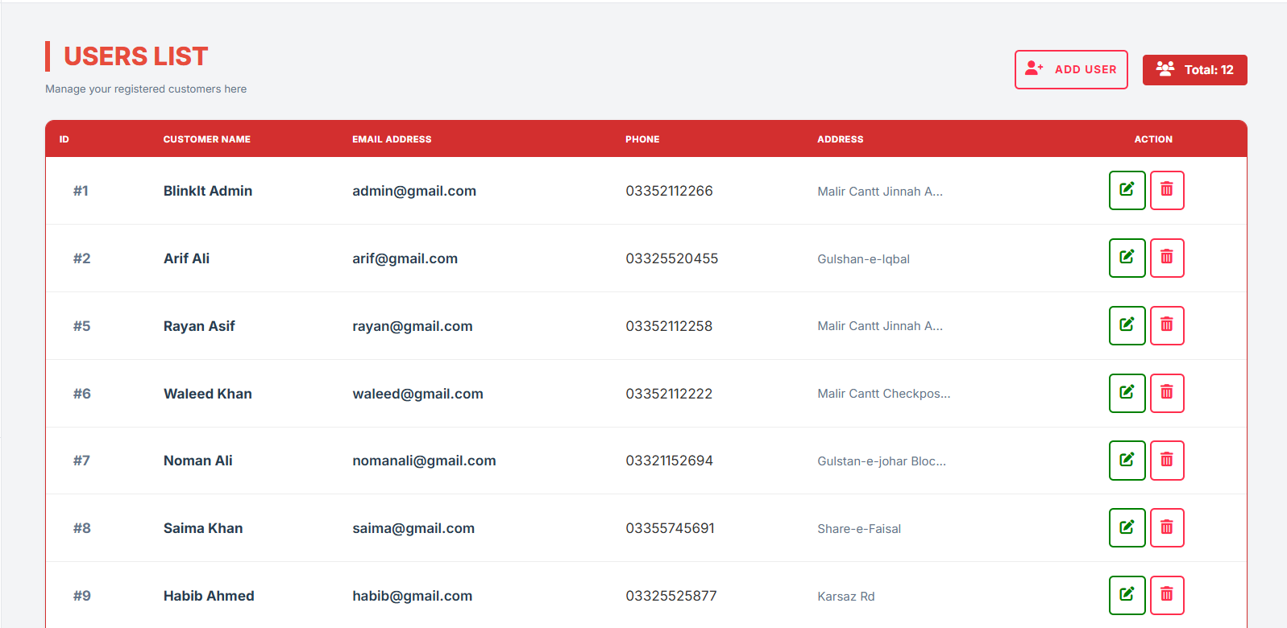

6.Invoice Generation
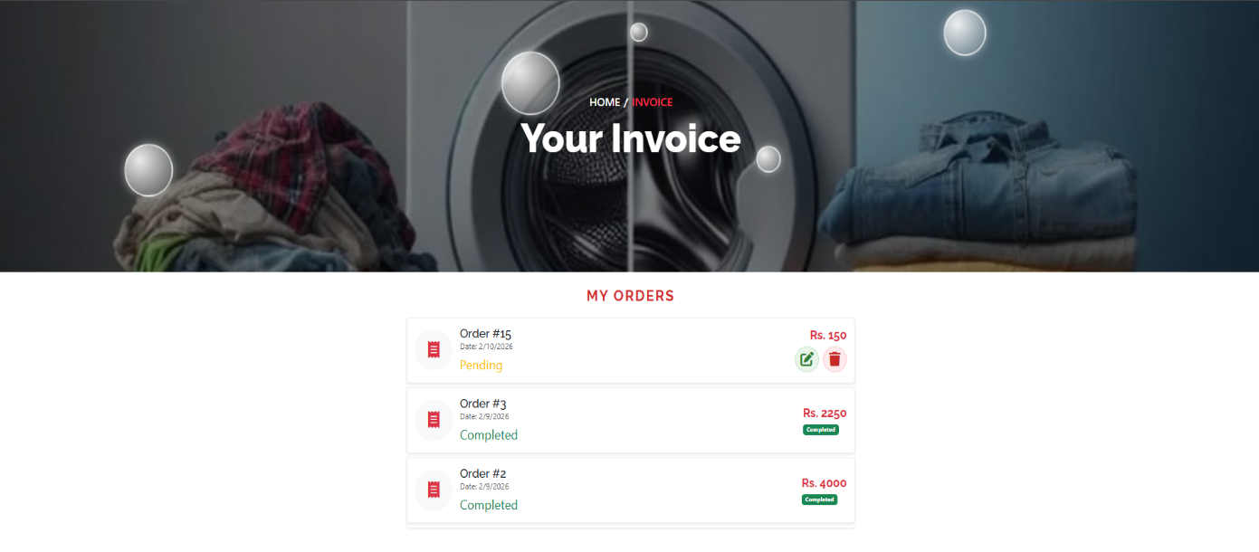

7a) Pricing (Order Placement Weight Wise, Package Wise)
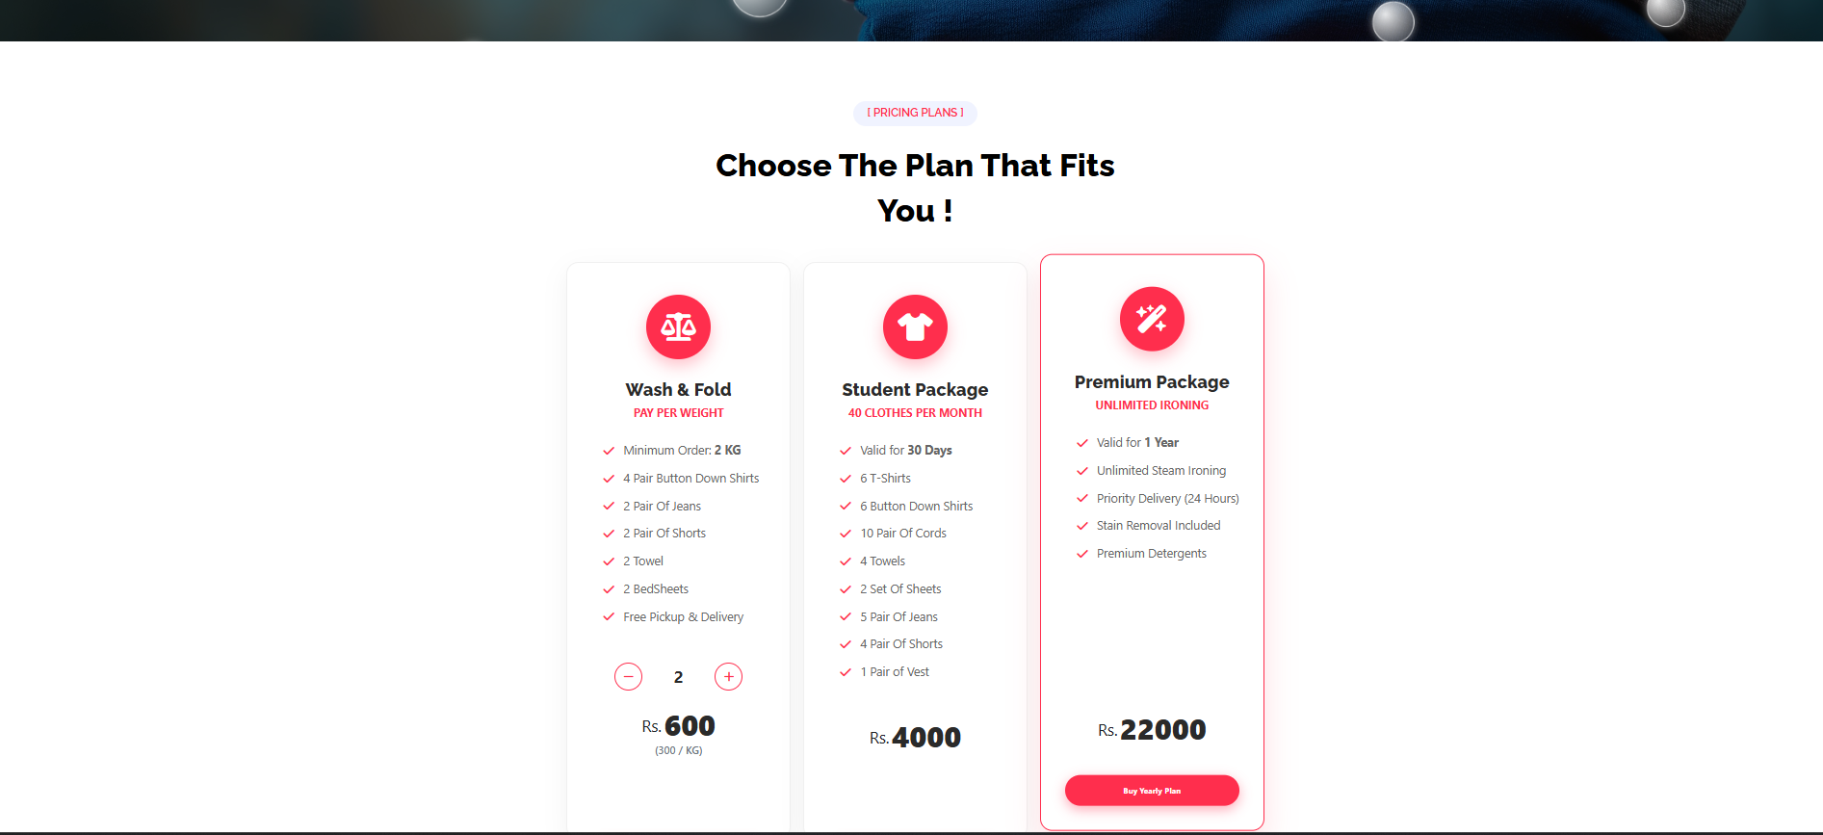

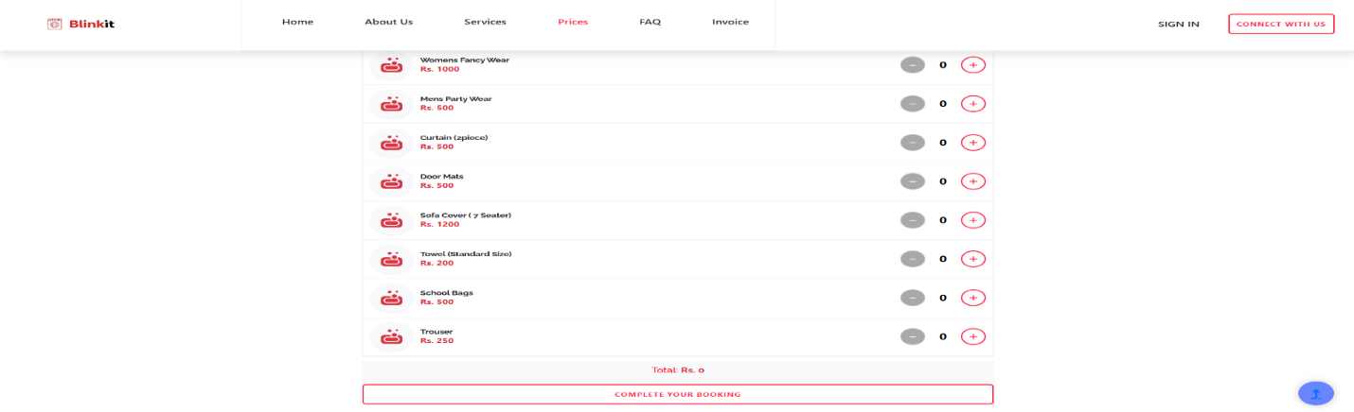
7b) Pricing (Piece Wise)

  - Barcode Generation

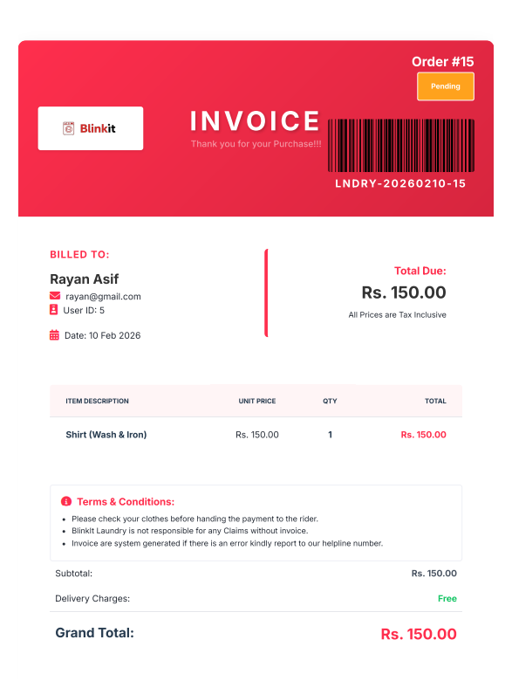
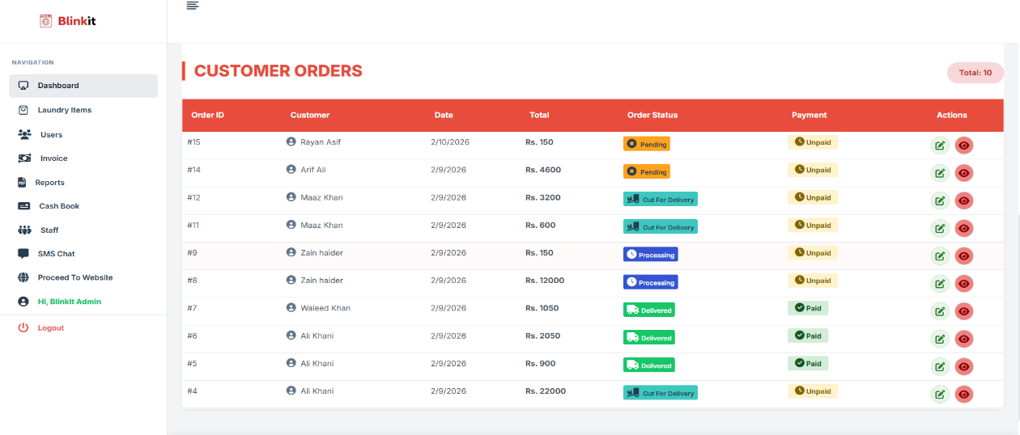
  - Admin (Order Management)

  - Reports 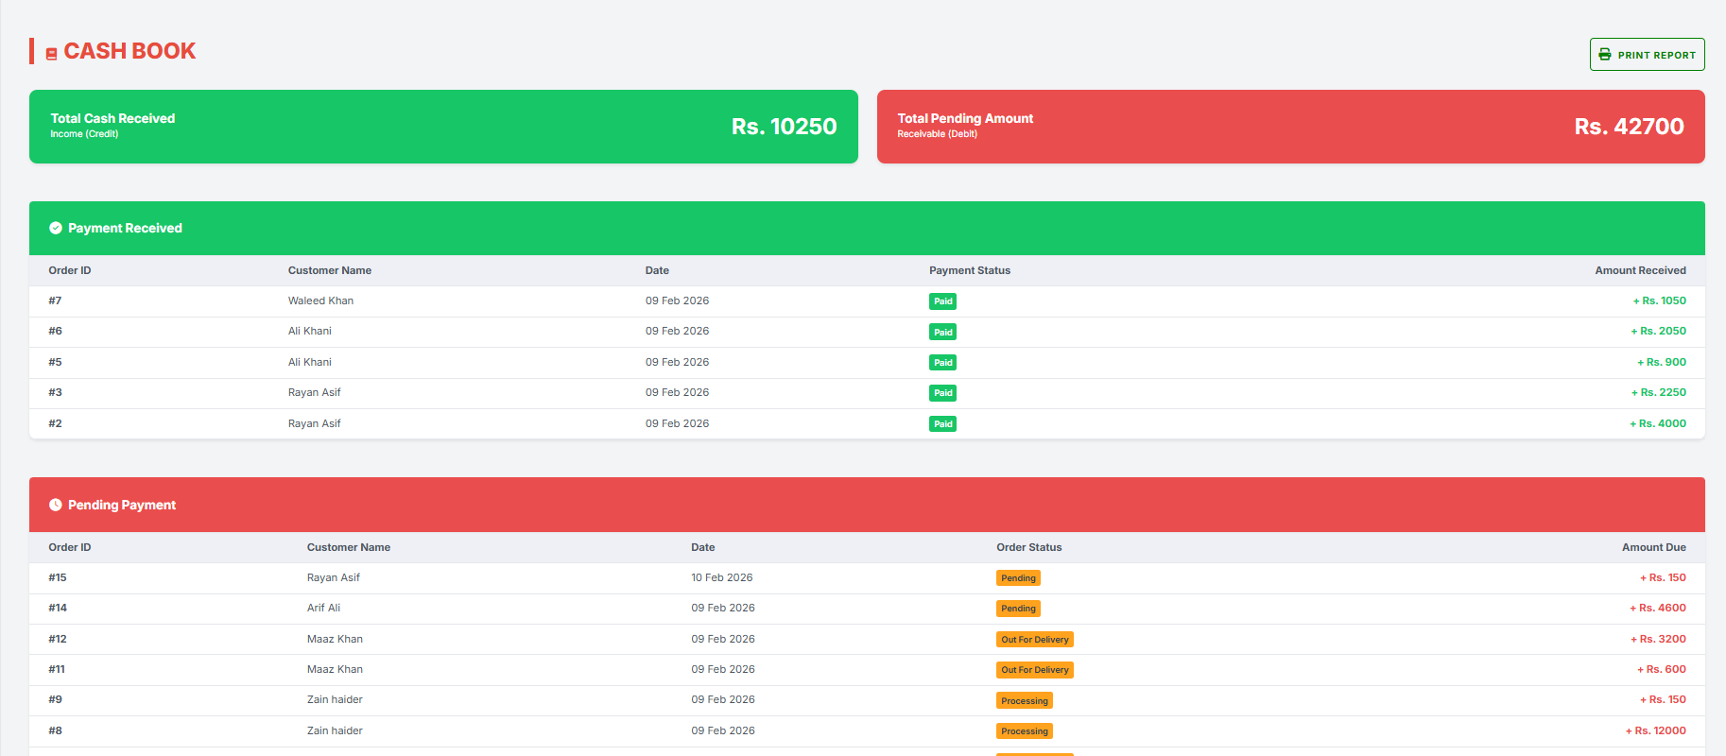
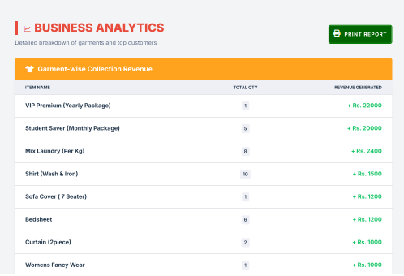
II) Business Revenue

III) Top Customers

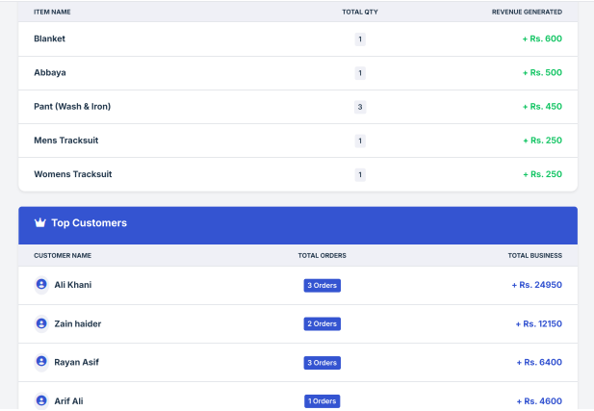

  - Chat System

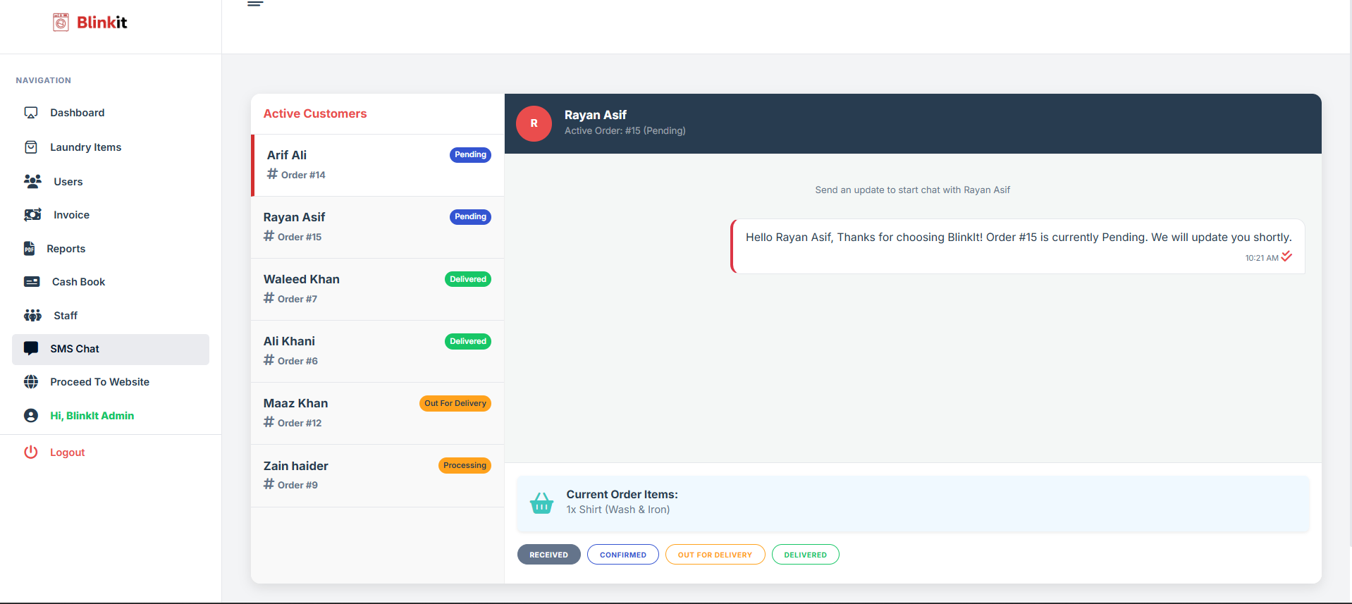

CHECKLIST
S/No | Features | Status
 | Customer Registration (Register new customer with basic info.) | Completed
 | Admin Rights (Full control to Edit, View, Delete data.) | Completed
 | Invoice Generation (Generate Bill/Invoice for orders.) | Completed
 | Service Types (Piece-wise & Weight-wise calculation also packages wise) | Completed
 | Cash Book Report (View Total Income & Daily Collection. Pending amounts for order) | Completed
 | Garment-wise Report (Revenue generated per item.) | Completed
 | Delivery Status (Track: Pending, Processing, Delivered.) | Completed
 | Barcode Generation (Tagging clothes for tracking.) | Completed
 | SMS Integration (Notifications on status change giving updates regarding their order) | Completed

